Construction/Build of the basics with distant websites

Introduction
A basic website was built to make a panel of different values to compare for gps coordinates see below.

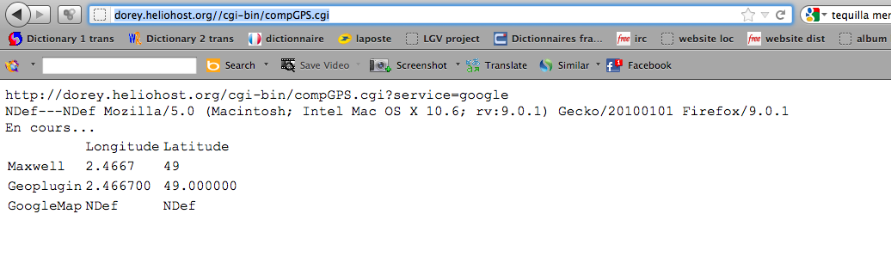
GPS coordinates

Basics
To achieve this project perl was used. CGI was necessary to make it happens. JavaScript was a perfectly used in HTML pages. Now it was necessary to use something that store data.

The drawing
A CGI script is written and hosted. It receives a basic http request from a browser. For the time being browser brand is not important. The CGI script interpret the request and send a HTML page to browser that is waiting an answer. Once the it is received the browser interprets what is received. If the there is javascript in it JavaScript is interpreted locally (where the browser is).
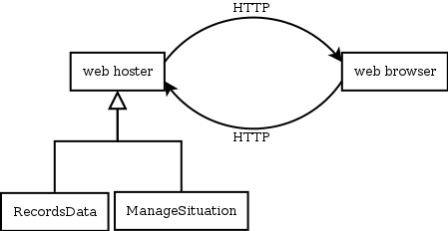
Basic representation of exchange between a browser and web server

Now how about making the results printed saved on the server. First attempt is to make it executed the script as if it is distant. The heck is that what is returned is the script interpreted on the browser not the value for JavaScript. Another choice is to make execute another service that is hosted elsewhere. There you get some values. When you receive them you can work on but as html or XML format. Now there is no JavaScript. Values are coded.

Differences
The browsers have no impact on the value received. The service that they offer can. All browsers interpret HTML 4 but not all HTML 5. One browser:



A comparison with different browsers:
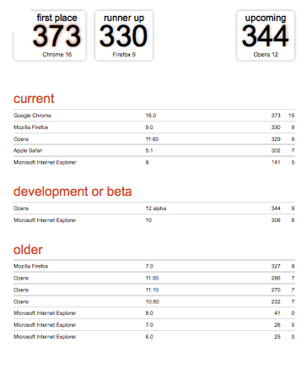

Some solution persist. The basic is ok now. May be using Ajax can be a solution?

The code at server side
#!/usr/bin/perl

use CGI;
use strict;
#use LWP::UserAgent;
use LWP;
# will do weather forecast
# use module
use XML::Simple;
use Data::Dumper;

use io::MySec;
use io::MyNav;

my $mcgi=new CGI;
my $serv=$mcgi->param("service");
my $rec=();

print "Content-type: text/html\n\n";
if("$serv" eq "google"){
print <<GPS;
<script language="JavaScript" src="http://www.geoplugin.net/javascript.gp" type="text/javascript"></script>
<script type="text/javascript" src="http://www.google.com/jsapi?key=ABQIAAAAO3m8Ej0Lg8Y0CEbotFaCRhQf4HhQWU1BJ6HFjMXkLlupKjyNORTWeHCgnHqZz-Zn96kXXmCsK_O1Bw"></script>

<!-- Google Gears -->
<script src="http://code.google.com/apis/gears/gears_init.js"></script>

<!-- Geo-location-javascript : http://code.google.com/p/geo-location-javascript/ -->
<script src="../geo-location-javascript/js/geo.js"></script>

<script type="text/javascript">
if(google.loader.ClientLocation) {
visitor_lat = google.loader.ClientLocation.latitude;
visitor_lon = google.loader.ClientLocation.longitude;
} else {
visitor_lat = "NDef";
visitor_lon = "NDef";
}
document.write(visitor_lon+ ","+visitor_lat);
</script>
GPS
}else{
my $browser = LWP::UserAgent->new( );
my $main_prog=(split(/[\\\/]/,"$0"))[scalar(split(/[\\\/]/,"$0"))-1]; # gets program name
my $host=(defined $ENV{HTTP_HOST}) ? $ENV{HTTP_HOST} : "nd";
if("$host" eq "localhost"){
$host.='/~sdo/';
}
my $resGoogle="http://$host/cgi-bin/$main_prog?service=google";# make url that query google services
#print "---->$resGoogle\n<br>\n";
print "---->\n";
my $response = $browser->get("$resGoogle");
if ($response->is_success) {
print $response->content();
}else{
print $response->content();
die("error $!");
}
print "\n<br>\n";
my $mach=(defined $ENV{HTTP_USER_AGENT}) ? $ENV{HTTP_USER_AGENT} : "nd";

chomp($host);
$rec="$mach||";

# Gets gps coordinates
my ($La,$lo)=getsGPSCoordinates();
print <<GPSThirdParty;
<html>
<head>
<title>Comparison of gps values with third party services</title>
<script language="JavaScript" src="http://www.geoplugin.net/javascript.gp" type="text/javascript"></script>
<script type="text/javascript" src="http://www.google.com/jsapi?key=ABQIAAAAO3m8Ej0Lg8Y0CEbotFaCRhQf4HhQWU1BJ6HFjMXkLlupKjyNORTWeHCgnHqZz-Zn96kXXmCsK_O1Bw"></script>
</head>
<body>
$mach<br>
<table>
<tr><td></td> <td>Longitude</td> <td>Latitude</td></tr>
<tr><td>Maxwell</td> <td>$lo</td> <td>$La</td> </tr>
<tr><td>Geoplugin</td> <td><script>document.write(geoplugin_longitude());</script></td> <td><script>document.write(geoplugin_latitude());</script></td> </tr>
<tr><td>GoogleMap</td> <td><script>document.write(visitor_lon);</script></td> <td><script>document.write(visitor_lat);</script></td> </tr>
<div id="maposition"></div>
</table>
<!-- Un élément HTML pour recueillir l’affichage -->

<script>

// Fonction de callback en cas de succès
function succesGeo(position) {
var infopos = "<td>geo-location-javascript:</td>";
infopos += "<td>"+position.coords.longitude+" </td>";
infopos += "<td>"+position.coords.latitude +"</td>";
//document.getElementById("maposition").innerHTML = "<table border=1><tr>"+infopos +"</tr></table>";
document.getElementById("maposition").innerHTML = "<tr>"+infopos +"</tr>";
}

// Fonction de callback en cas d’erreur
function erreurGeo(error) {
var info = "<td>geo-location-javascript</td>";
///var info = "Erreur lors de la géolocalisation : ";
info += "<td>" + error.message + "</td>" ;
document.getElementById("maposition").innerHTML = "<tr>" + info + "</tr>" ;
}

// Initialisation du framework et géolocalisation
if(geo_position_js.init()){
document.getElementById("maposition").innerHTML = "En cours...";
geo_position_js.getCurrentPosition(succesGeo,erreurGeo);
} else {
alert("Ce navigateur ne supporte pas la géolocalisation");
}

</script>

</body>
<script language="JavaScript" src="http://www.geoplugin.net/javascript.gp" type="text/javascript"></script>
</html>
GPSThirdParty
}

sub checksFile{ # begin sub checksFile
if(!open(R,"$0")){ # begin if(!open(R,"$0))
return -1;
} # end if(!open(R,"$0))
close(R);
return 0;
} # end sub checksFile

The code client side (execution at client side)

